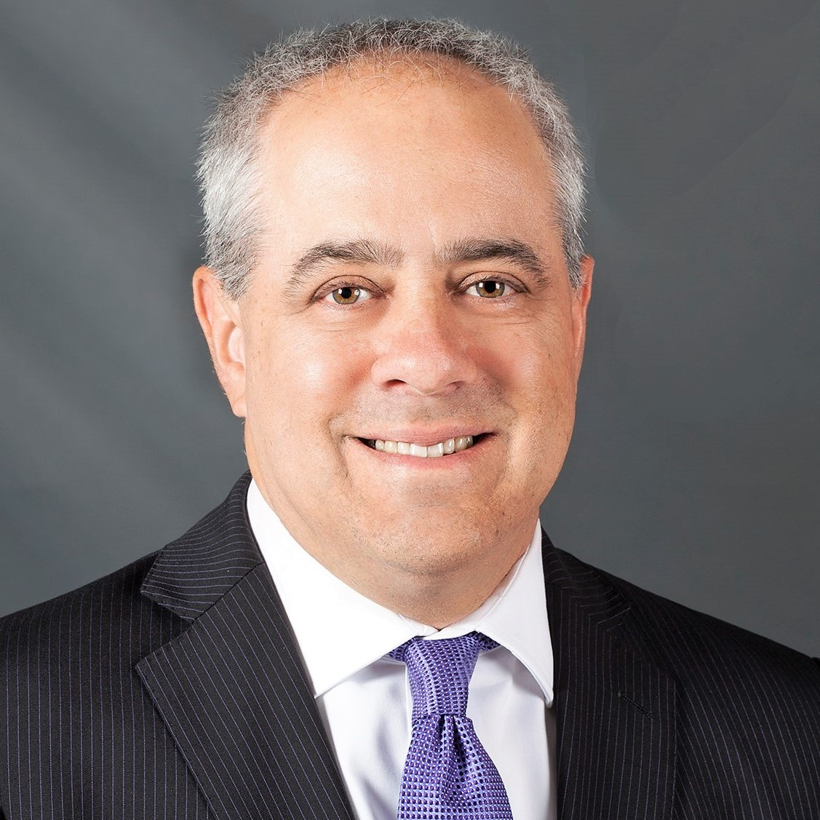
For additional information, contact:
HW Financial Advisors
216.595.6400

www.hwfa.com
Stephen Rudolph, MBA, CPA

Stephen Rudolph of HW Financial Advisors Named to
Forbes’ Best-in-State Wealth Advisors List

FOR IMMEDIATE RELEASE

Beachwood, OH (January 23, 2020)—HW Financial Advisors, today announces that its President, Stephen Rudolph, MBA, CPA, has been named to Forbes’ Best-in-State Wealth Advisors list for 2020. The list was published on Forbes.com, and a condensed listing will be available in Forbes February issue.

Steve has over two decades of experience working with high net worth individuals. He believes in a personalized approach that includes frequent client contact, educating individuals and providing solutions for their unique needs. Steve has a strong interest in behavioral finance and why investors make poor decisions. He believes in a client-centered, conflict-free advisory philosophy.

“I am honored to be included in the prestigious Forbes list of top wealth advisors in Ohio! I am very grateful to work with tremendous clients and a fantastic team at HW Financial Advisors.”

Wayne Bloom, CEO of Commonwealth Financial Network®, HW Financial Advisors Registered Investment Adviser–broker/dealer, said, “Congratulations to Stephen Rudolph on this well-earned recognition by Forbes. Steve is committed to providing expert guidance and essential support to his clients, and we are proud to provide HW Financial Advisors with the business solutions they need to power their practice.”

The 2020 ranking of the Forbes’ Best-in-State Wealth Advisors¹ list was developed by SHOOK Research and is based on in-person and telephone due-diligence meetings to evaluate each advisor qualitatively and on a ranking algorithm that includes client retention, industry experience, review of compliance records, firm nominations, and quantitative criteria (including assets under management and revenue generated for their firms). Overall, 32,000 advisors were considered, and 4,000 (12.5 percent of candidates) were recognized. The full methodology² that Forbes developed in partnership with SHOOK Research is available here.

About HW Financial Advisors
HW Financial Advisors has been providing individuals and organizations with financial guidance since 1999. Located at 23240 Chagrin Blvd, Suite 880, Beachwood, OH, (216.595.6400) the firm prides itself on crafting unique strategies for each client. For more information, please visit www.hwfa.com.

Advisory services offered through Commonwealth Financial Network®, a Registered Investment Adviser

¹ This recognition and the due-diligence process conducted are not indicative of the advisor’s future performance. Your experience may vary. Winners will be organized and ranked by state. Some states may have more advisors than others. You are encouraged to conduct your own research to determine if the advisor is right for you.
² Portfolio performance is not a criterion due to varying client objectives and lack of audited data. SHOOK does not receive a fee in exchange for rankings.
# # #

